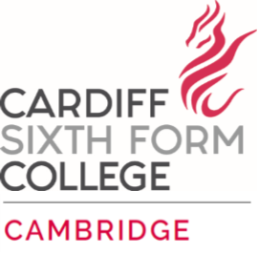
Candidate Information Pack
Graduate Residential Assistant

The college seeking to employ a boarding graduate residential assistant

The Graduate Residential Assistant will join the existing boarding team will oversee the well-being and pastoral care of students.

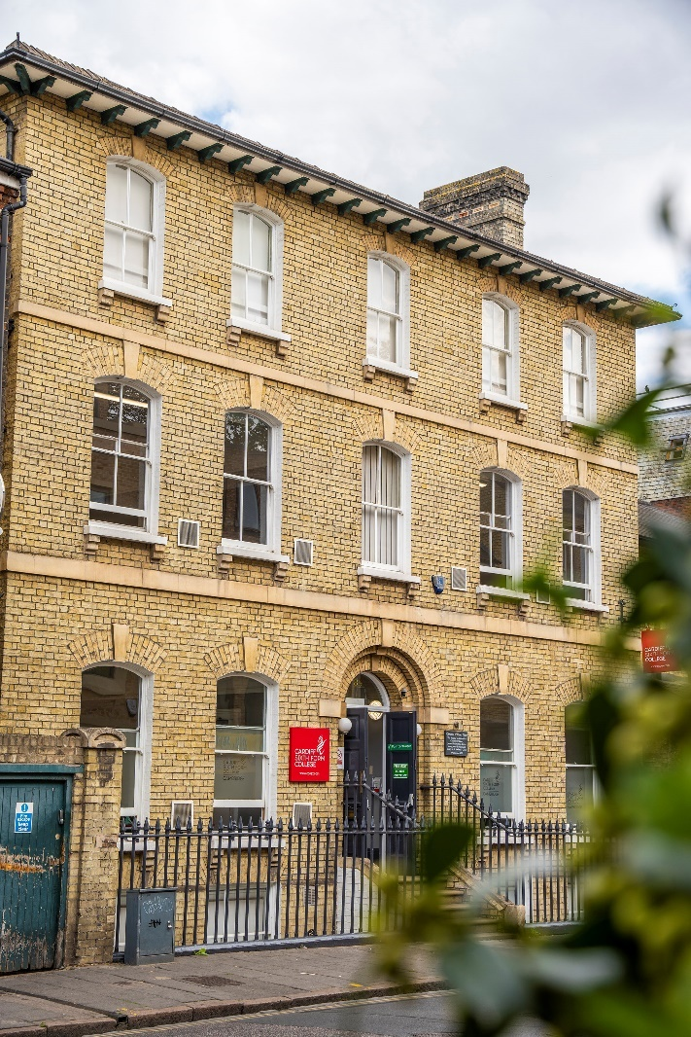

What would you do if you worked in a school with the most able students from across the world?
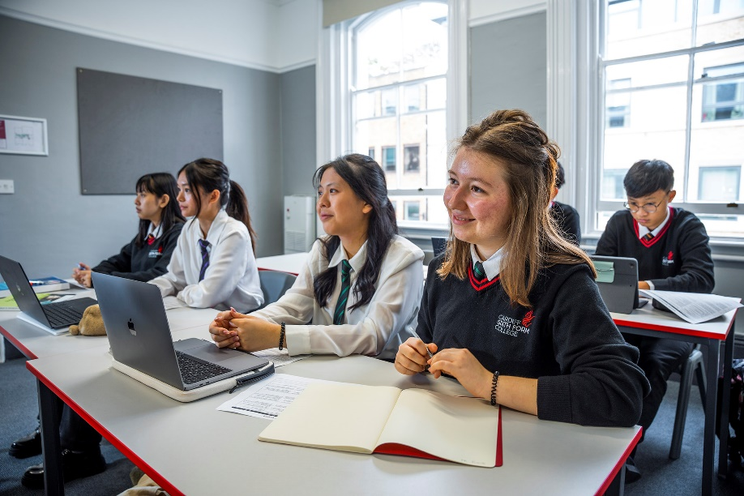
Introduction & Background
Cardiff Sixth Form College was set up in 2004 as a small private tutorial centre in response to a perceived need in the community to cater for those students of high academic ability but relatively modest financial means. Latterly, expansion of the college has allowed for international students to access this same service. The aim of Cardiff Sixth Form College is to prepare students for a well-balanced, modern life with outstanding levels of educational achievement. A combination of small class sizes, individual attention and excellent teaching leads to first-class academic results with the college being recognised consistently as the ‘Number One Independent School in the UK, at A Level’ since 2011.
Cardiff Sixth Form College is an international boarding school which brings together some of the most talented students from different countries, providing a stimulating environment in which to study. Students bring an enthusiasm and focus to their studies and are hungry for knowledge and success. In 2021, 98% of students achieved A*-A grades and 100% A*-B. 17 students went on to Oxbridge and 50% to the G5 universities with 81% going onto QS Top 100 universities worldwide.
The opening of a new site in Cambridge in September 2022 means that both Cardiff and Cambridge colleges now operate as ‘One College, on Two Campuses’.
Location
Cardiff Sixth Form College, Cambridge is set in the heart of the city of Cambridge. Based in three buildings, closely located to the town centre, it is very much an ‘urban college’.
Cambridge is a city on the River Cam in eastern England, home to the prestigious University of Cambridge, dating to 1209. University colleges include King’s, famed for its choir and towering Gothic chapel, as well as Trinity, founded by Henry VIII, and St John’s, with its 16th-century Great Gate. University museums have exhibits on archaeology and anthropology, polar exploration, the history of science and zoology.
The city's skyline is dominated by several college buildings, along with the spire of the Our Lady and the English Martyrs Church, and the chimney of Addenbrooke's Hospital. Anglia Ruskin University, which evolved from the Cambridge School of Art and the Cambridgeshire College of Arts and Technology, also has its main campus in the city.
Cambridge is at the heart of the high-technology Silicon Fen with industries such as software and bioscience and many start-up companies born out of the university. Over 40 per cent of the workforce have a higher education qualification, more than twice the national average. The Cambridge Biomedical Campus, one of the largest biomedical research clusters in the world includes the headquarters of AstraZeneca, a hotel, and the relocated Royal Papworth Hospital.
The first game of association football took place at Parker's Piece, immediately behind the Cardiff Sixth Form College main building. The Strawberry Fair music and arts festival and Midsummer Fair are held on Midsummer Common, and the annual Cambridge Beer Festival takes place on Jesus Green.
The city is well served with excellent road and rail links. It is adjacent to the M11 and A14 roads and Cambridge station is less than an hour from London King's Cross railway station.
School Aims & Ethos
Cardiff Sixth Form College’s vision is to be “The Best Academic School in the World”: lofty aspirations which are backed up by a remarkable history of high academic achievement and successful university placements.
Ralph Waldo Emerson said: “Without ambition one starts nothing. Without work one finishes nothing. The prize will not be sent to you. You have to win it.” This epitomises the attitude of a typical Cardiff Sixth Form College student who is ambitious, whose aspirations are broad and whose academic dreams are significant. It is for the hardworking and diligent student who wants to excel and broaden their academic horizons. It is for students who wish to win a place at the best universities to study courses which will provide fulfilment and challenge. It is not for everyone, but it is the perfect place for many.
The college aims to deliver teaching and learning that challenges, inspires, demands and delivers excellence; careers guidance which is outstanding and is tailored to the individual’s needs and aspirations; pastoral care which is safe, caring, compassionate, understanding and developmental; administration which is efficient and supportive, with compliant systems, both complementing and leading the provision; and sustainability that comes from a profitable organisation that invests for and in the future.

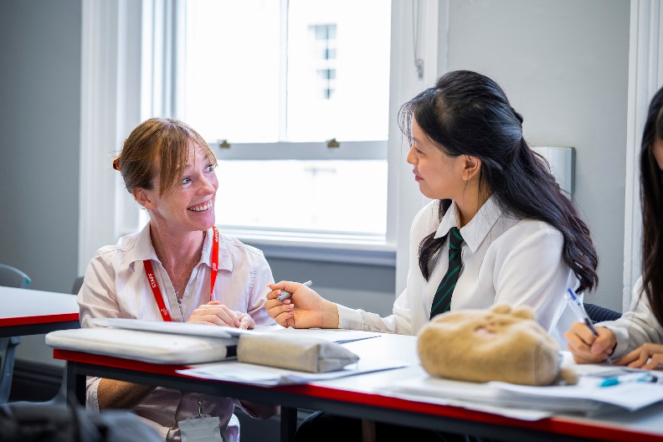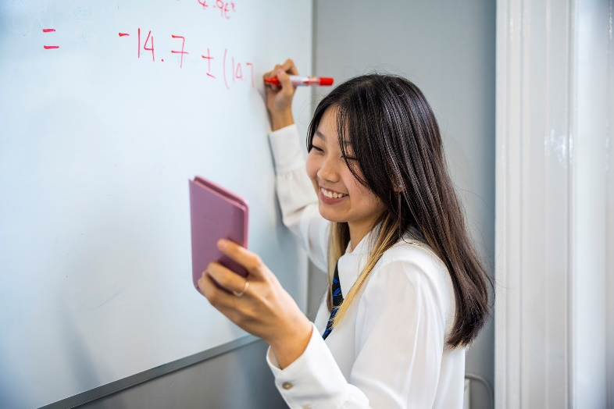

Cardiff Sixth Form College’s new Cambridge campus
As the leading A level provider within the UK, Cardiff Sixth Form College offers an outstanding academic programme for admission to the best universities in the UK and internationally. At the Cambridge campus, students will follow a predominantly STEM programme and may select from the following subjects:
Biology | Further Mathematics | Mathematics | Chemistry | Physics | Economics | Computer Science
In addition, the college helps students build management and project skills, teamwork abilities, confidence and a healthy mindset. Our teaching approach places considerable emphasis on independent learning – to look beyond simple answers and demonstrate a passion for knowledge and discovery. To support this aim, all students have access to courses in critical thinking, effective communication, leadership and entrepreneurship.
Learning begins in the classroom but doesn’t end there. All students take part in an extensive super-curricular programme, ‘The Cambridge Edge’. This including elements from work observation, academic enrichment trips, career-based societies and a wide range of academic competitions.
An extensive university preparation programme complements the curriculum, giving students the best chance to achieve their potential. This includes specific assistance for Oxbridge entry, Medicine and Healthcare degrees and international university preparation. As a part of Dukes Education, we are supported by Dukes Consultancy, including Oxbridge Applications, Medic Applications and A List for US University Applications in providing expert and bespoke assistance to our students.

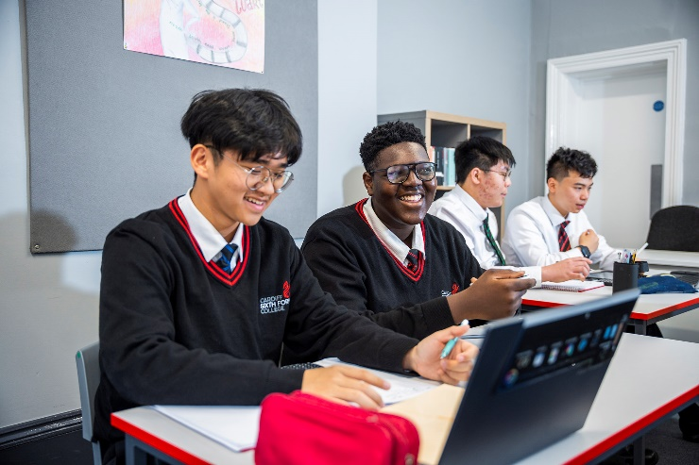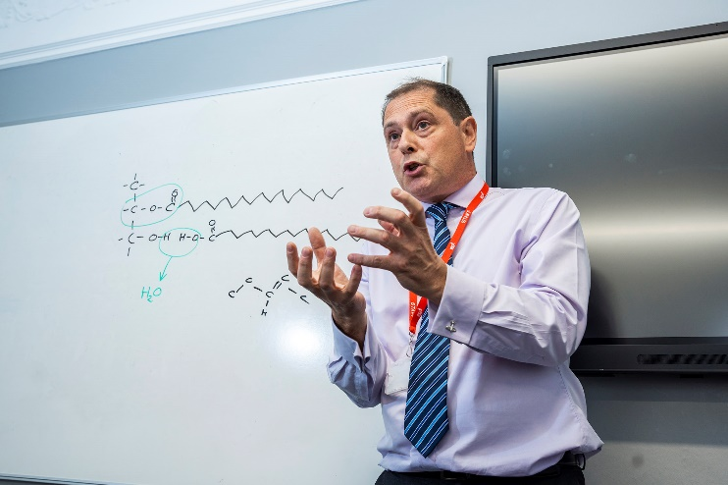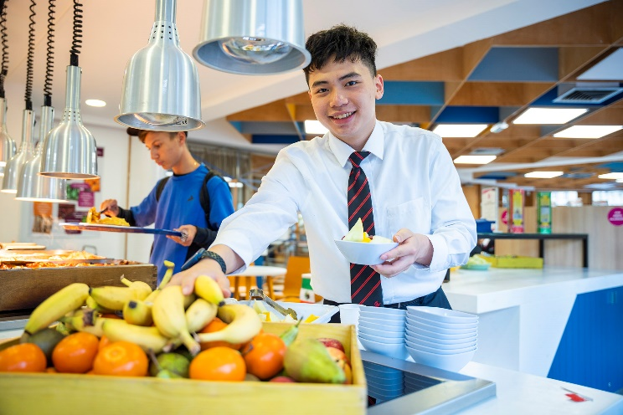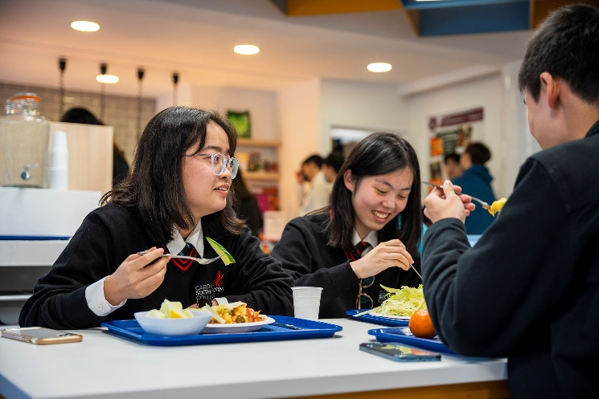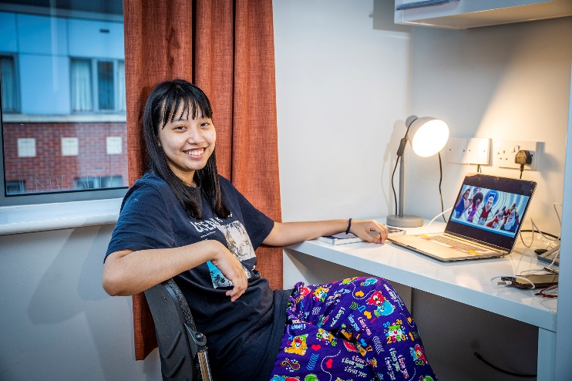

Graduate Residential Assistant at CSFC Cambridge
Cardiff Sixth Form College Cambridge was launched in September 2022 with a small cohort of international students. The college will grow substantially in September 2023 and resulting in a number of additional boarding staff roles becoming available.
The Gradate Residential Assistant will join the existing boarding team to provide pastoral care of the highest standard that inspires our able and ambitious students to develop as young people outside of the classroom

JOB DESCRIPTION
Job Title: | Boarding Graduate Residential Assistant (GRA)
Department: | Boarding
Responsible to: | Head of Pastoral through Senior Houseparent
Purpose of the job: | The main purpose of the job is to help look after the safety and welfare of the pupils/students in the boarding house and contribute to the wider framework of the College by participating in a range of trips, activities, career and academic opportunities. Graduate Residential Assistants are a vital link between the pupils/students, Pastoral and Academic/Administration staff.  Graduate Residential Assistants are responsible to the Head of Pastoral through the Senior Houseparent. They are expected to live in and sleep on site throughout the week when on duty except on their weekend or evenings off, and to take most of their meals with students and other staff. Graduate Residential Assistants occupy a special position in the House as pupils’/students’ confidantes and friends, but they are first and foremost members of staff and must always ensure that their behaviour reflects that prime responsibility. Appropriate staff training and induction will be given to cover Safeguarding, First Aid, Fire Training, Child Protection Training,  Pupil/Student Welfare & Counselling.

Organisation of the House

- Prioritise pupil/student facing activities and duties & Positively promote staff presence in the boarding house focusing on particularly busy areas of the house;
- Help promote and organise pupil/student run activities;
- Assist the Head of Pastoral, Senior Houseparent and Houseparents with administration and office tasks as required, liaising between pupils/students and administration staff;
- Maintain any promotional material about the House, providing current information and photographs to the College Marketing Department as required;
- Attend weekly staff meetings as required.

Social & Pastoral Welfare

- Support the pastoral team in creating a warm and friendly atmosphere and fostering a happy community spirit, especially for pupils/students newly arrived at the College;
- Promote an environment where the pupils/students feel heard and suggestions on how to improve life in boarding can be improved;
- Complete training in Safeguarding, Child Protection, Food safety and any other areas relevant to the safe running of the boarding house;
- Read, understand, and sign the staff handbook and all relevant school policies and procedures (safeguarding, bullying policy, online safety, etc.);
- Work extensively as part of a team and report any pupil/student concerns as and when

these arise to the Head of Pastoral and the safeguarding team.
- Uphold the rules of the house and pass on breaches of the rules to the Houseparent or Senior Houseparent;
- Assist the medical team with accompanying pupils/students to Hospital or doctors’ appointments;
- Ensure that pupils/students uphold the high standards of school uniform and conform to the college uniform policy;
- Engage in evening and weekend pastoral duties & activities, supervising students’ welfare;
- Taking a leading role in promoting and taking part in the extra-curricular and super- curricular programme, for example, ranging from the NASA competition to the Football Team and Glee Club. This may vary from accompanying staff on excursions to leading excursions.

Other
- Sign and comply with a Service Agreement which specifies CSFC’s expectations of staff conduct within the boarding house.
- Work within other areas of the College such as Careers, Marketing and Admin, and complete tasks accordingly.
- Establish and maintain an exciting and vibrant atmosphere in the House including regularly updating noticeboards and information displays in a professional manner designed both to inform and promote the College and opportunities provided for pupils/students.
- Help monitor and manage attendance in the mornings; along with uniform.

Job Skills
Graduate Residential Assistants are expected to bring to the role specific attributes relating to their academic qualifications, social and personal development and past experiences. These could be from but are not limited to:
- Sports coaching skills.
- Music playing and tuition skills.
- Speech and Drama skills.
- Academic skills.
- Charitable activity skills.

Person Specification
- Caring and sensitive approach to the needs of all pupils/students.
- Appreciation, understanding and willingness to work with pupils/students from a wide variety of nationalities, religions and backgrounds.
- Ability to carry out tasks and instructions reliably and efficiently.
- A cheerful and willing disposition.
- Flexibility and enthusiasm.
- Attention to detail.
- Good ICT skills.

Cardiff Sixth Form College winning the ‘Overall Setting of the Year’ Award at the 2022 Annual Dukes Education Conference.
